**3 oldest players:**  
SELECT id,player_name, birthday FROM Player order by birthday LIMIT 3metin, yazı tipi, ekran görüntüsü, beyaz içeren bir resim

Açıklama otomatik olarak oluşturuldu

**3 youngest players:**

SELECT id,player_name, birthday FROM Player order by birthday desc LIMIT 3 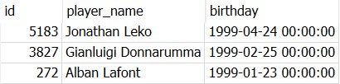

**Shortest player:**

SELECT player_name,MIN(height) FROM Player



**Tallest player:**

SELECT player_name,MAX(height) FROM Player



**3 players with highest overall rating:**

SELECT DISTINCT player_api_id,overall_rating FROM Player_Attributes order by overall_rating desc LIMIT 3

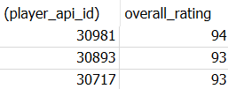

SELECT player_api_id,player_name FROM Player where player_api_id in (30981,30893,30717)

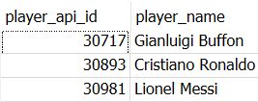

**2 best goalkeepers:**

SELECT DISTINCT player_api_id,gk_positioning

FROM Player_Attributes order by gk_positioning desc LIMIT 2

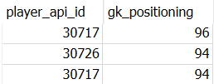  
SELECT player_api_id,player_name FROM Player where player_api_id in (30726,30717)  
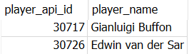

**2 fastest players:**

SELECT DISTINCT player_api_id,sprint_speed

FROM Player_Attributes order by sprint_speed desc LIMIT 2  
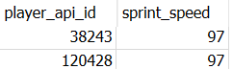

SELECT player_api_id,player_name FROM Player where player_api_id in (38243,120428)

metin, yazı tipi, ekran görüntüsü, çizgi içeren bir resim

Açıklama otomatik olarak oluşturuldu

**Teams playing with Highest Presure and Offside Trap**:

SELECT team_fifa_api_id,defencePressureClass,defenceAggressionClass,

defenceTeamWidthClass,defenceDefenderLineClass

FROM Team_Attributes GROUP BY defenceDefenderLineClass, defenceTeamWidthClass,defenceAggressionClass,defencePressureClass

HAVING defencePressureClass = "High" and defenceDefenderLineClass = "Offside Trap"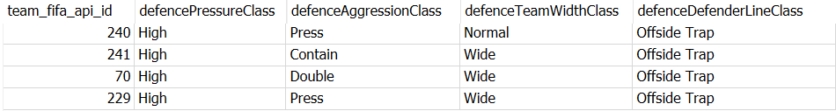

SELECT team_fifa_api_id,team_long_name,team_short_name

FROM Team where team_fifa_api_id in (70,229,240,241)

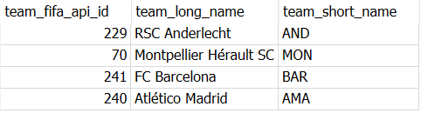

**Teams playing atacking football with Short Passes**:

SELECT team_fifa_api_id,buildUpPlaySpeedClass,buildUpPlayPassingClass, chanceCreationShootingClass FROM Team_Attributes

WHERE chanceCreationShootingClass = "Lots" and buildUpPlayPassingClass = "Short" and buildUpPlaySpeedClass="Fast"

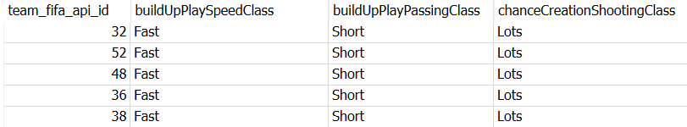

SELECT team_fifa_api_id,team_long_name,team_short_name

FROM Team where team_fifa_api_id in (32,36,38,48,52)  
